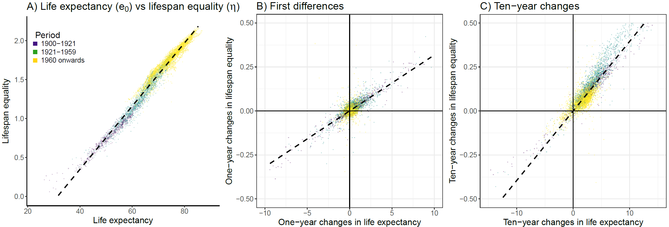**Fig. 1 Panel A. Association between life expectancy and lifespan equality ($η$). Panel B. Association between changes in life expectancy and lifespan equality. Panel C. Association between changes over ten-year periods in life expectancy and lifespan equality.**

**Fig. 2 Weights for the changes in life expectancy $w(x)$ (panels A and B) and lifespan equality $w\left(x\right)W_{η}(x)$ (panels C and D). Each line refers to a given period. They represent how life expectancy and lifespan equality react to age-specific mortality improvements over time. The dashed lines in panels C and D represent the age that separates increase from decrease in lifespan equality as a results of mortality improvements in a given age and period (see Box 1).**

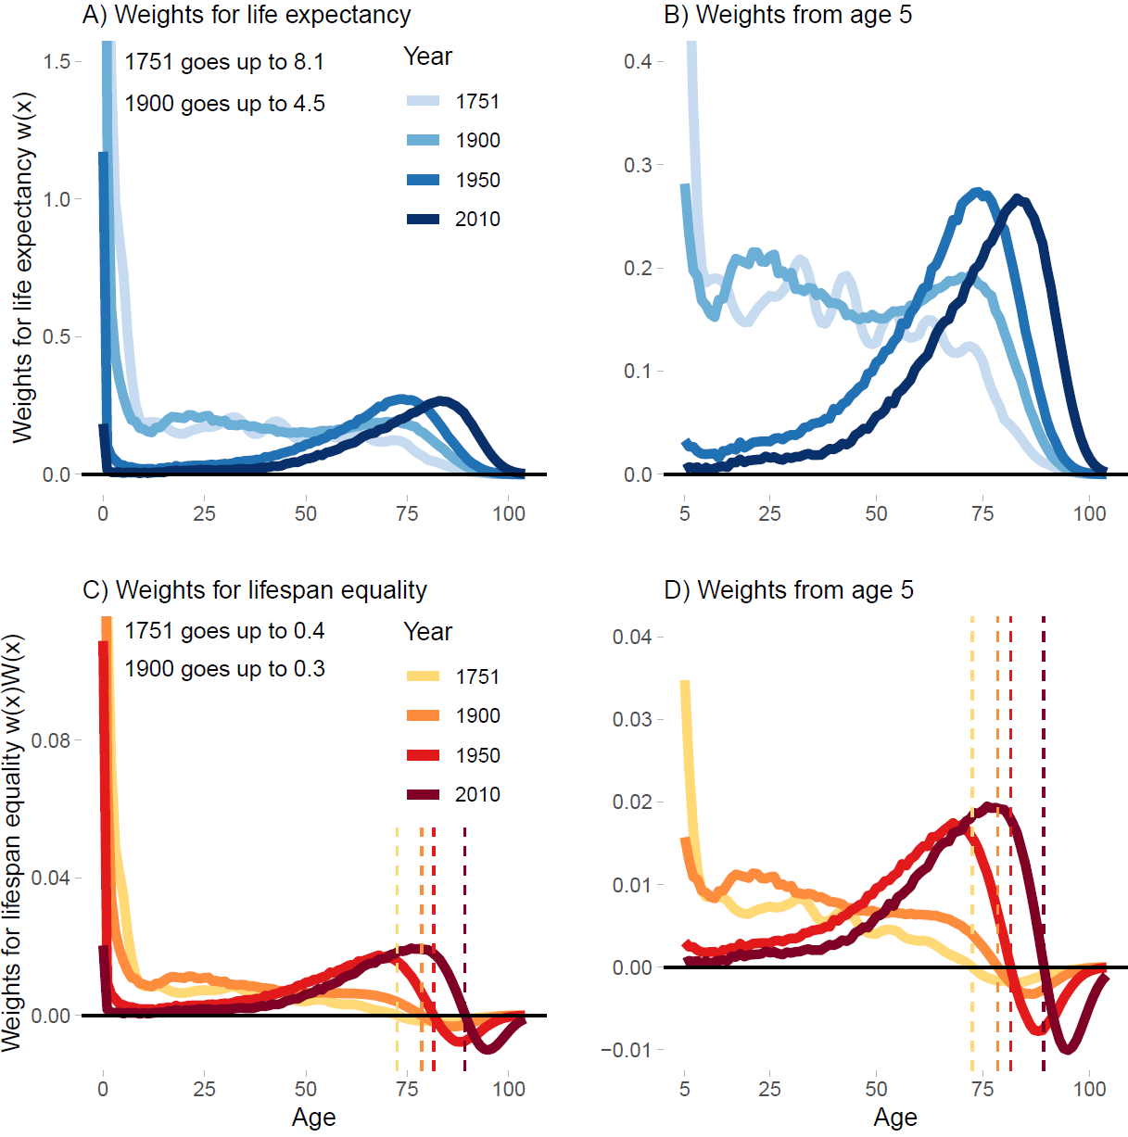

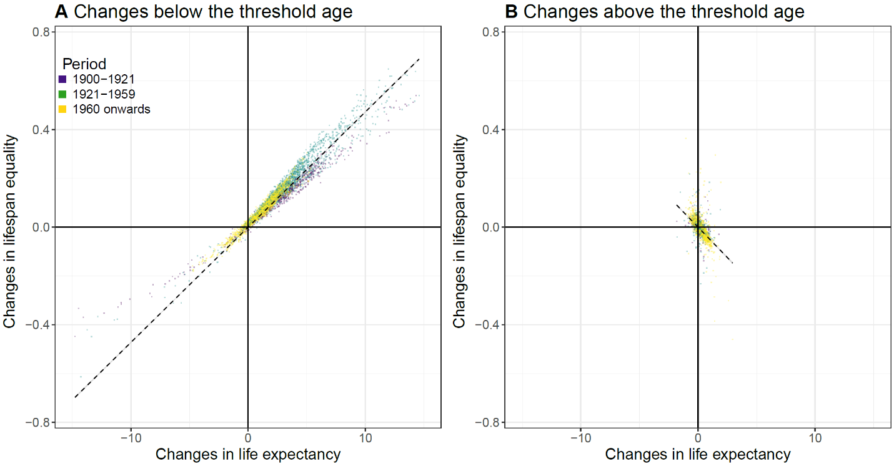**Fig. 3. Panel A. Association between 10-year changes in life expectancy and lifespan equality ($η$) below the threshold age. Panel B. Association between 10-year changes in life expectancy and lifespan equality above the threshold age. Dotted lines show the directions of the relationship below and above the threshold age.**

**Fig. 4 Life expectancy at birth and lifespan equality ($η$) for three different scenarios: 1) Observed points: Swedish females 1751--2016; 2) Optimal equality: lifespan equality derived by matching observed life expectancy levels by reducing the youngest age; and 3) Constant change ($ρ$) over age matching observed life expectancy levels.**

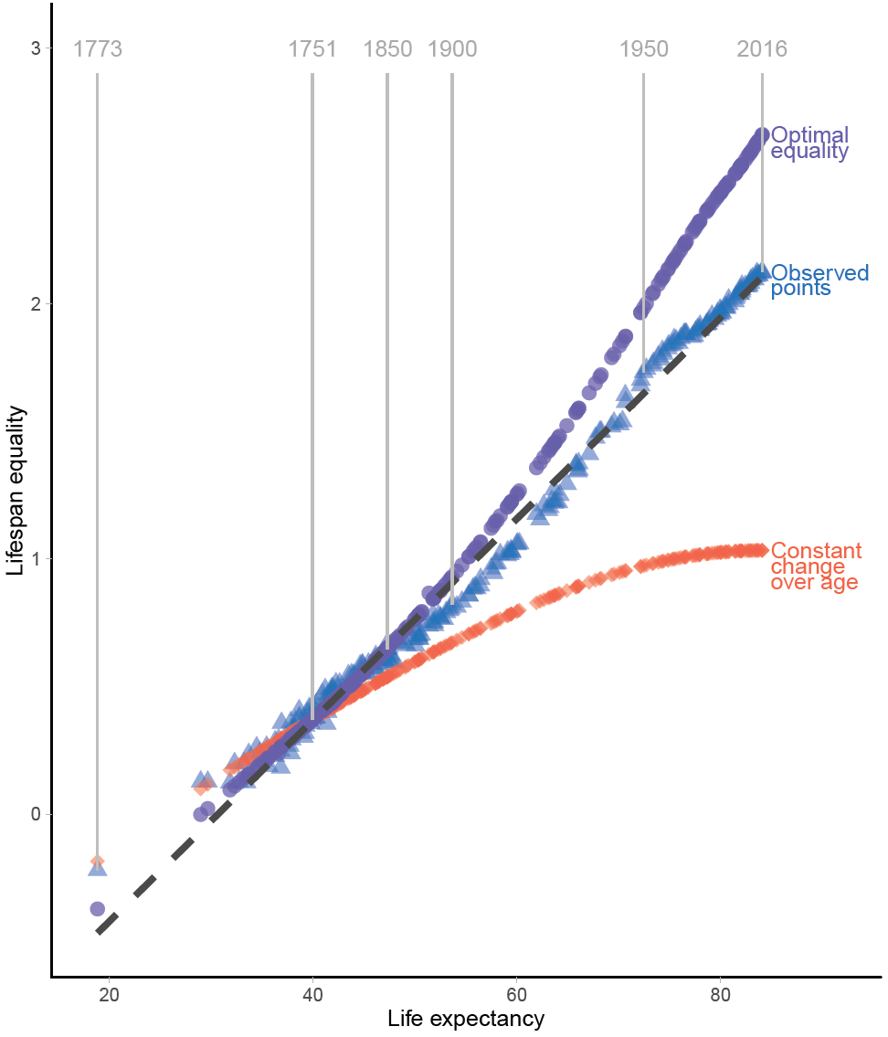

**Box Fig**

